Module:-Dashboard
1) In the Dashboard module, when attempting to upload data, the form opens but displays a warning message stating, “Something went wrong. Please try again later.” Additionally, there is a spelling error in the message 1.
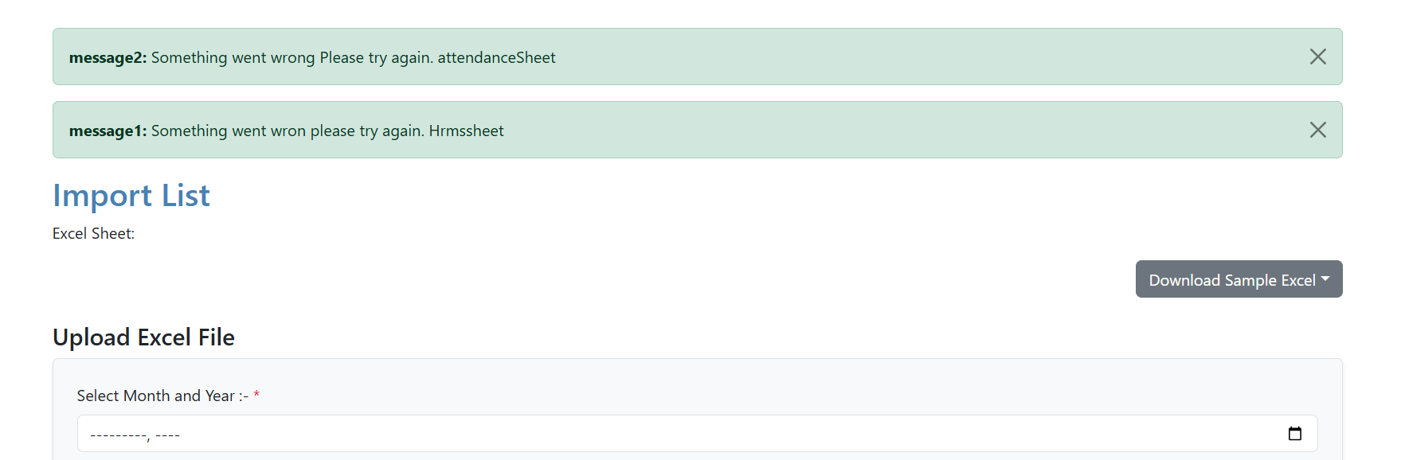
2)If any sheet is downloaded, this message is displayed. However, from a user’s perspective, this message is unnecessary.

3)The overtime sheet downloads successfully, but it is not in a proper Excel format and the data is not aligned. Please convert it into a well-formatted Excel file.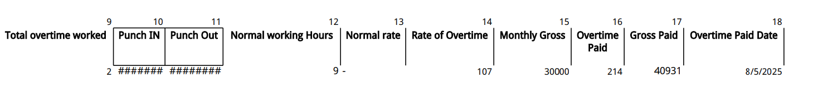

4)After downloading not showing in the proper excel format
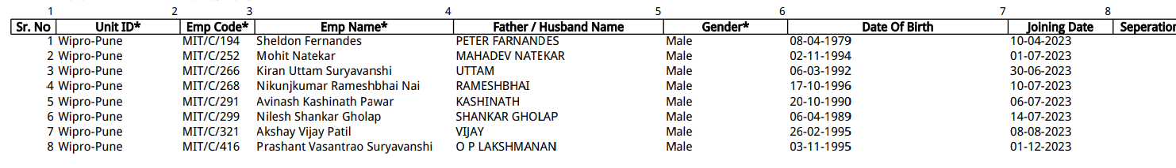

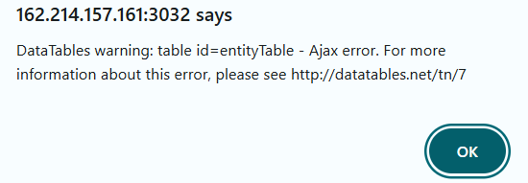
5) The system should block or restrict the Excel file upload when required options are skipped. Currently, it still allows the document to be uploaded, which is incorrect.
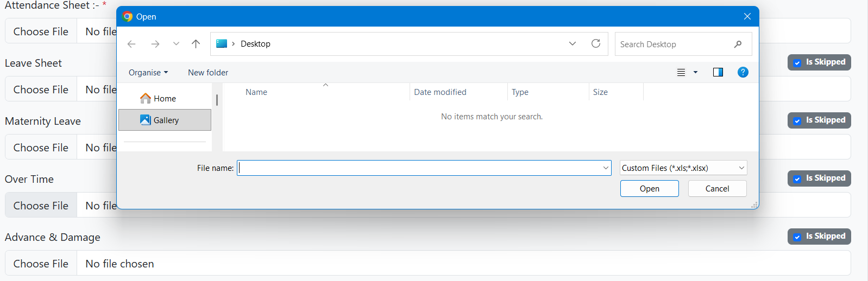

6)HRMS and Attendance files are required. However, when I do not upload the HRMS and Attendance files, the system displays an incorrect message:
“HRMS_AND_PAYSHEET file is required and cannot be empty.”
The message should be:
“HRMS_AND_ATTENDANCE file is required and cannot be empty.”
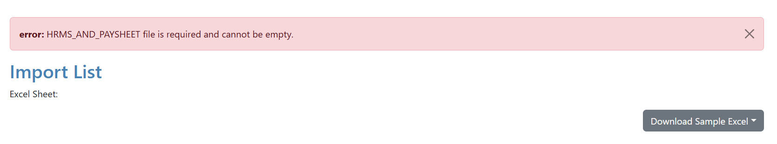
7) In the Dashboard module, when we go to the Upload Data option and open the form, the text fields for HRMS and Paysheet, Attendance Sheet, Leave Sheet, Maternity Leave, Over Time, and Advance & Damage display a placeholder (“No file chosen”). There is a spelling mistake in this placeholder.
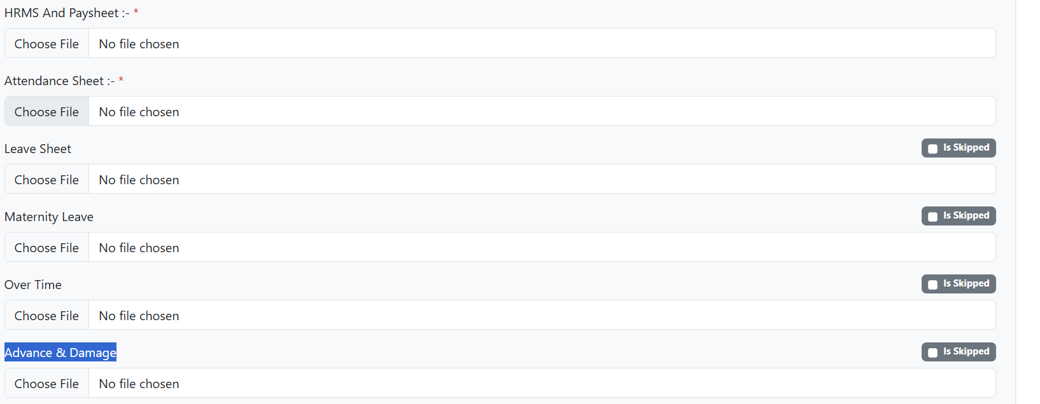

*Module:- User Mapping
1)In user mapping search button , edit button, delete button and add button is not working.
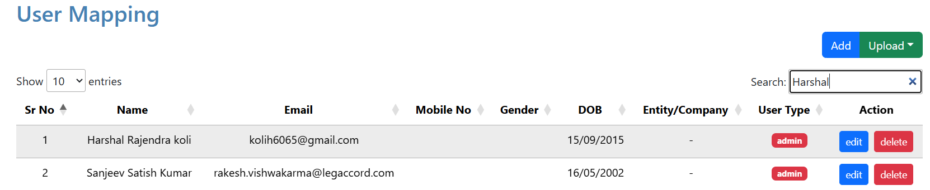

*Module:-State
1) In the State module, while editing the Name field (textarea), the system currently allows the input of numeric values and special characters. This behavior should be restricted to accept only alphabetic characters, as per the expected validation rules.
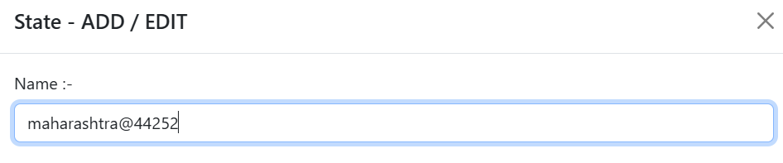
2) In the State module, when you try to delete a state, it is not actually deleted—it is only deactivated. However, the system still shows a delete warning message, which is misleading.
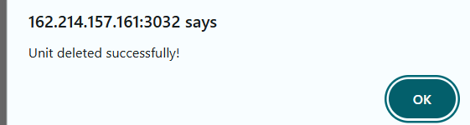

*Module:-Location/Branch
1)In the Location module, when using the search button to find a city name, the system filters results correctly if fewer than 4 characters are entered. However, when more than 3 characters are entered, it does not filter the city name and instead displays “No data available”.
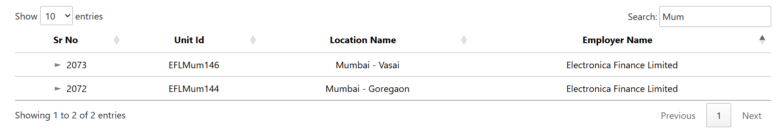
More than 3 characters
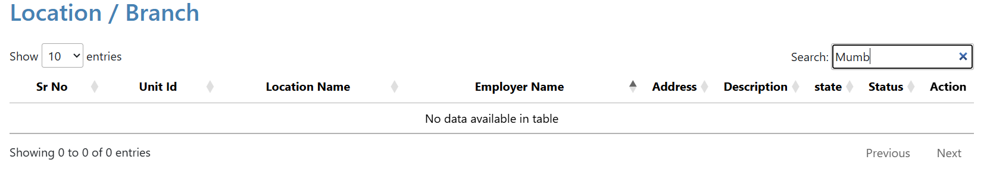

*Module:-Add Entity/Company
1)In the Add Entity module, when editing an existing record, the Name text field accepts numeric values as well as special characters, which should not be allowed. 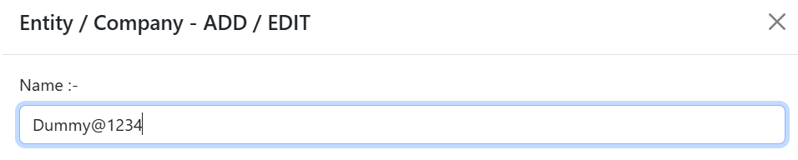

2) Within the Add Entity module, executing a search operation triggers the display of database warning messages.
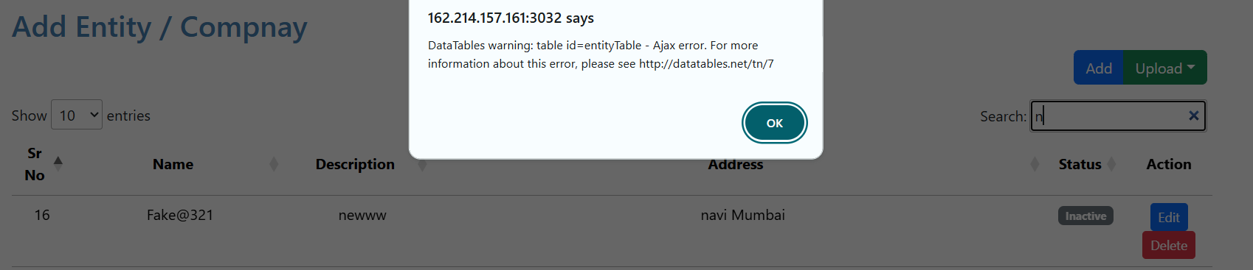

3) In the Add Entity module, deleting a specific record does not remove it from the system. Despite a success message indicating deletion, the entity is only marked as inactive.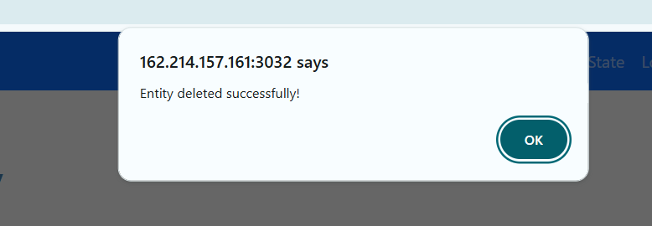

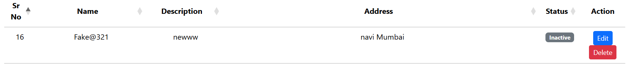
*Module:-Documents
1) In the Documents module, the search only filters by Unit ID. It should also filter by State and Company.
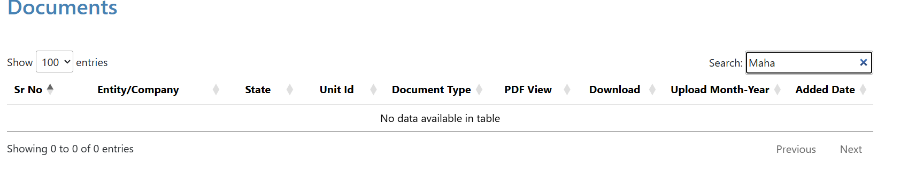

2) In the Dashboard module, when opening the file upload section, there is an option called CLRA at the end. When selecting CLRA, additional options should appear for selection, but currently no options are available.